

ZAMBIA

# Introduction

# _____________________________________________________

# Each year, tobacco costs the Zambian economy ZMW 2.8 billion, equivalent to 1.2 percent of its GDP.* These costs include a) ZMW 154 million in healthcare expenditures, and b) ZMW 2.7 billion in lost productive capacities due to premature mortality, disability, and workplace smoking. The productivity losses from current tobacco use in Zambia – 94.5 percent of all tobacco-related costs – indicate that tobacco use causes problems in Zambia far beyond the health sector; multi-sectoral engagement is required for effective tobacco control, and other sectors benefit substantially from supporting tobacco control investments(about USD 299.3 million as of 2017).[1]

# The COVID-19 pandemic has brought many social and economic burdens in many communities and the nation at large, in Zambia. This situation has inadvertently created an opportunity for the tobacco industry to offer various kinds of donations of goods and funds as a way to supplement government’s efforts. However, opening the door to the tobacco industry’s charity also paves the way to a relationship that the industry will exploit to further its business. A collaborative relationship with the industry serves to undermine tobacco control.

# Tobacco users are more vulnerable during the pandemic and known to suffer more severe symptoms if infected with COVID-19. The tobacco industry continued to produce cigarettes and sell them during the pandemic putting profits before health.

Zambia signed the World Health Organization Framework Convention on Tobacco Control (WHO-FCTC) on 23rd May, 2008 and ratified the treaty a legal action indicating the country’s consent to be bound by its terms on 21st August, 2008. As a Party to the convention, the country is expected to have taken measures compliant with the Framework Convention on Tobacco Control to protect its citizens from the deadly effects of tobacco.

The most critical measure the government has been expected to take is to domesticate the WHO-FCTC through the enactment into law of the Tobacco and Nicotine Products Control Bill of 2018. However, government through the last session of Parliament which dissolved on 14th May, 2021, failed to push the Bill for enactment. Zambia is going to hold general elections on 12th August his year and the Bill was expected to have been enacted before the dissolution of Parliament.

All key stakeholders holders had been consulted and contributed towards the contents of the Bill which is now pending at the Ministry of Heallth before it could be taken to Cabinet for approval and finally taken to Parliament for debate and eventua enactment.

Nonetheless, the failure to pass the Bill means that tobacco control advocates will have to start all-over again engaging and educating the new lawmakers after the general elections on the importance of passing the Bill into law in order to promote public health against the effects of tobacco products consumption.

About 90% of tobacco grown in Zambia is exported mainly to China and other countries.

This is Zambia’s second country report on tobacco industry interference. In 2020, the country scored 78/100, indicating a very high level of tobacco industry meddling in policy development. This year, Zambia garnered again an overall score of 78/100, which equally indicates a weak approach of the government in protecting public health policies and lawmaking from tobacco industry interference.

This report uses the questionnaire developed by the Southeast Asia Tobacco Control Alliance (SEATCA) based on the Article 5.3 of the FCTC Guidelines. Information used in this report is obtained from the public domain. A scoring system is applied to make the assessment. The score ranges from 0 - 5, where 5 indicates highest level of industry interference, and 1 is low or no interference. Hence the lower the score, the better for the country. This report gathers evidence for the period January 2020 to March 2021.

**Summary Findings**

**__________________________________________________________________________________**

## INDUSTRY PARTICIPATION IN POLICY DEVELOPMENT

The tobacco industry through its front groups such as the Tobacco Board of Zambia (TBZ) has been pushing for formulation of favourable tobacco legislations that would promote production and increase business at the expense of public health. TBZ Chief Executive Officer is quoted in one of the daily newspapers of having said: “And in terms of its contribution to the GDP, in 2013 it contributed about 3% but currently we are contributing about 1% and it’s an indication that the industry is not doing well,”[2] he said. If you look at production volumes and foreign exchange generated from tobacco in Malawi and Zimbabwe, you can see that the potential is enormous for Zambia, he further said.

He lamented one of the most important factors which urgently needs to be addressed is the need to have a conducive legal framework which will fully meet the business aspirations of the industry as the current Tobacco Act Cap 237 was last reviewed in 1968 hence the business model on how people operate within the industry has completely changed.

## 

## INDUSTRY CORPORATE SOCIAL RESPONSIBILITY (CSR) ACTIVITIES

In June 2020, the Japan Tobacco International (JTI) spent US$300,000 providing materials towards the fight against corona virus in health facilities and schools in Western and Eastern provinces[3].

Kaoma District Commissioner Kennedy Mubanga then disclosed this when he and his counterpart Nkeyema District Commissioner Albertina Mwanamwalye received the donation from JTI on behalf of the Government institutions. Mr. Mubanga commended JTI for supplementing Government’s efforts in curbing further spread of coronavirus in health facilities and schools through the provision of materials.

## BENEFITS TO THE INDUSTRY

The long delay in the filing of the Control of Tobacco Products Bill has benefited the tobacco industry to increase its business. There is no ban on tobacco advertising, CSR activities are allowed enabling industry executives close access to government officials and leaders, no pictorial warnings on cigarette packs and sale of cheap single sticks make cigarettes both affordable and accessible[4].

## UNNECESSARY INTERACTION

In 2020, acting Minister of Commerce, Trade and Industry Mutotwe Kafwaya toured the BRITISH American Tobacco (BAT) Zambia Plc processing plant and following the visit BAT claimed that they have invested an additional US$800,000 in its production line and assured support in contributing to Zambia’s economic development agenda.

In April 2021, former Zambian Republican President Rupiah Banda toured the offices and warehouses of the Japan Tobacco International in Chipata where he alleged that the country’s good investment policies are attracting foreign investment and investors need good investment policies.[5]

## TRANSPARENCY

The government does not publicly disclose its meetings/ interactions with the tobacco industry. The Zambian government has not put in place a procedure to disclose its meetings with the tobacco industry. However, this requirement is already proposed in the Tobacco Products and Nicotine Products Control Bill of 2018.

An example of government’s non-disclosure of meetings with the tobacco industry is a stakeholders meeting held on 19th February, 2021 in Kaoma district, Western Province. During this meeting, Tobacco Board of Zambia (TBZ) represented government. Copies of the agenda of the meeting are attached as evidence. ANNEX A

## CONFLICT OF INTEREST

## The Electoral Act (2006) of Zambia has no provisions on the raising and expenditure of party funds. The Societies Act, under which parties are registered, requires that parties make some disclosure of their financial records to the Registrar of Societies, but places no restrictions on how money is raised or spent. The Registrar of Societies is not obliged to disclose these records unless she believes it is in the interest of party members to do so.

## PREVENTIVE MEASURES

There is no documented evidence that government has put in place a procedure for disclosing the records of its interaction with the tobacco industry and its representatives.

The government has not formulated, adopted or implemented a code of conduct for public officials, prescribing the standards with which they should comply in their dealings with the tobacco industry.

# Recommendations

**_____________________________________________________**

1. Prohibit all CSR activities by the tobacco industry in accordance with the WHO FCTC.
2. Raise awareness among all government agencies about the WHO FCTC Article 5.3.
3. Enact the pending Tobacco and Nicotine Products Control Bill 2018 to protect public health from tobacco industry interference. An FCTC Article 5.3 provision in the draft Bill should be maintanined.
4. Adopt a code of conduct for all public officials to guide them when dealing with the tobacco industry and limit interactions between the government and the tobacco industry to only when strictly necessary.

# 2021 Tobacco Industry Interference Index

# Results and Findings

|  | **0** | **1** | **2** | **3** | **4** | **5** |
| --- | --- | --- | --- | --- | --- | --- |
|  | | | | | | |
| **INDICATOR 1: Level of Industry Participation in Policy-Development** | | | | | | |
| 1. The government[6] accepts, supports or endorses any offer for assistance by or in collaboration with the tobacco industry[7] in setting or implementing public health policies in relation to tobacco control[8] (Rec 3.1) |  |  |  |  |  | **5** |
| The Tobacco Products Control Bill of 2016 has been languishing. Despite following a multisectoral approach in developing the Tobacco Control legislation, Ministry of Commerce, Trade and Industry, Ministry of Agriculture and Ministry of Finance opposed the Bill. Industry involvement was noticed by British American Tobacco presence. The current tobacco control law in Zambia is outdated, not FCTC compliant.  Consultative meetings for the preparation of the bill began many years ago in 2011. The long delay in the passing of the bill points to interference from the tobacco industry. | | | | | | |
| 1. The government accepts, supports or endorses policies or legislation drafted by or in collaboration with the tobacco industry. (Rec 3.4) |  |  |  |  | **4** |  |
| Meanwhile, the Tobacco Board of Zambia (TBZ) Chief Executive Officer[9] is promoting to protect the tobacco industry; to ensure that the industry reaches its potential, there is a need to urgently amend the outdated 1968 legislation (Tobacco Act Cap 237); that the legislation must be updated to empower the business to attract more buyers in Zambia and to help small and medium scale farmers with favourable interest rates. He is requesting for a conducive legal framework which will fully meet the business aspirations of the tobacco industry.  The TBZ has since advocated for the updating of the legal framework which if well formulated and implemented will attract more investors and buyers on the Zambia market, help establish a robust auction system, aid investment protection by eliminating vices such as tobacco vending as well as avail the key tobacco players source financing to fund extensive out-grower schemes.  In May 2020 the Agriculture Minister Micheal Katambo announced to revamp the production of tobacco and make it a key export commodity, Cabinet has already authorized his Ministry to begin the process of reviewing tobacco legislation in collaboration with all stakeholders and proceed with amendment and updating of the legislation.  TBZ stated that Government has noted the continued decline in tobacco production which is unfortunate as it translates in a loss in foreign exchange earnings, and the reasons cited for the poor performance in the tobacco industry is outdated legislation hence, he pledged that his ministry proceed with amendment of the relevant legislation to stimulate the growth and re-energize the tobacco industry[10].  In 2021, the Eastern Fodya urged the government to put in place guidelines and measures that will not affect tobacco sales. This is after the government had restricted travelling due to the COVID-19 in 2020 (Annex F) | | | | | | |
| 1. The government allows/invites the tobacco industry to sit in government interagency/ multi-sectoral committee/ advisory group body that sets public health policy. (Rec 4.8) |  |  |  |  |  | **5** |
| While the government does not have the tobacco industry sitting in a multi-sectoral committee, however the government consults with the tobacco industry on decision concerning tobacco control. | | | | | | |
| 1. The government nominates or allows representatives from the tobacco industry (including State-owned) in the delegation to the COP or other subsidiary bodies or accepts their sponsorship for delegates. (i.e. COP 4 & 5, INB 4 5, WG)[11] (Rec 4.9 & 8.3) |  | 1 |  |  |  |  |
| The government does not allow representatives of the tobacco indusry in its delegation to the COP and its related meetings. The last COP was in 2018. | | | | | | |
| **INDICATOR 2: Industry CSR activities** | | | | | | |
| 1. A. The government agencies or its officials endorses, supports, forms partnerships with or participates in so-called CSR activities organized by the tobacco industry. (Rec 6.2)   B. The government (its agencies and officials) receives contributions[12] (monetary or otherwise) from the tobacco industry (including so-called CSR contributions). (Rec 6.4) |  |  |  | **3** |  |  |
| In June 2020, the Japan Tobacco International (JTI) spent US$300,000 providing materials towards the fight against corona virus in health facilities and schools in Western and Eastern provinces.  Kaoma District Commissioner Kennedy Mubanga disclosed this when he and his counterpart Nkeyema District Commissioner Albertina Mwanamwalye received the donation from JTI on behalf of the Government institutions. Mr. Mubanga commended JTI for supplementing Government’s efforts in curbing further spread of coronavirus in health facilities and schools through the provision of materials.  A total amount of USD 150,000 has so far been spent in Health facilities and schools and handed over to the respective beneficiaries in Kaoma and Nkeyema Districts,” he revealed. Mr. Mubanga said that the donation will improve the quality of teaching in schools and also assist health personnel as they execute their duties in the fight against the pandemic.  And speaking for Nkeyema District, Mrs. Mwanamwalye said the assistance could not have come at a better time than this when the two Districts were in need of protective materials for learners, teachers and health workers[13].  JTI1-300x200.jpg    ***Figure 1:*** *JTI supplementing Government’s efforts in curbing spread of COVID-19 in health facilities & schools*  On 14th August 2020, Ambassador of Japan to the Republic of Zambia, Mr. MIZUUCHII Ryuta, attended the handover ceremony for the Grassroots Human Security Projects titled “Project for the construction of Kabwata Development Youth Center in Lusaka”. Mr. Succeed Mubanga, Director of Planning and Information on behalf Hon. Brian Mushimba, Minister of Higher Education, His Worship Mr. Miles Sampa, The Mayor of Lusaka, Ms. Grace Mtonga, Director of Civic Forum on Housing and Habitat Zambia and other guests, totaling about 50 people were also present at the ceremony and celebrated the handover of the newly constructed building to the Given Lubinda Foundation, the main operator of the Center, The project, worth about USD103,106, aims at improving the access of academic and vocational skills for youth and thereby contributing to better employment opportunities for their lives. Four Japanese companies including JTI Leaf responded to the call for the donation.  C:\Users\Francis Lungu\Downloads\IMG-20210317-WA0016 (3).jpg    *Figure 2: Japanese Ambassador to Zambia Mr. Ryuta MIZUUCHII (second right) and Lusaka Mayor Miles Sampa at the handover ceremony for the construction of Kabwata Development Youth Centre in Lusaka, 14th August 2020* | | | | | | |
| **INDICATOR 3: Benefits to the Tobacco Industry** | | | | | | |
| 1. The government accommodates requests from the tobacco industry for a longer time frame for implementation or postponement of tobacco control law. (e.g. 180 days is common for PHW, Tax increase can be implemented within 1 month) (Rec 7.1) |  |  |  |  |  | **5** |
| The long delay in the filing of the Control of Tobacco Products Bill has benefited the tobacco industry to increase its business. There is no ban on tobacco advertising, CSR activities are allowed enabling industry executives close access to government officials and leaders, no pictorial warnings on cigarette packs and sale of cheap single sticks make cigarettes both affordable and accessible. | | | | | | |
| 1. The government gives privileges, incentives, exemptions or benefits to the tobacco industry (Rec 7.3) |  |  |  |  |  | **5** |
| International travellers entering Lusaka are allowed to bring in 400 sticks of cigarettes or 0.5 grams of pipe tobacco or 0.5 kg. cigars duty free.[14]  ANNEX A, D, E, F | | | | | | |
| **INDICATOR 4: Forms of Unnecessary Interaction** |  |  |  |  |  |  |
| 1. Top level government officials (such as President/ Prime Minister or Minister[15]) meet with/ foster relations with the tobacco companies such as attending social functions and other events sponsored or organized by the tobacco companies or those furthering its interests. (Rec 2.1) |  |  |  |  | **4** |  |
| Acting Minister of Commerce, Trade and Industry Mutotwe Kafwaya visited BAT’s facility in Lusaka. Annex B  In April 2021, former Zambian Republican President Rupiah Banda toured the offices and warehouses of the Japan Tobacco International in Chipata where he alleged that the country’s good investment policies are attracting foreign investment and investors need good investment policies. Annex C | | | | | | |
| 1. The government accepts assistance/ offers of assistance from the tobacco industry on enforcement such as conducting raids on tobacco smuggling or enforcing smoke free policies or no sales to minors. (including monetary contribution for these activities) (Rec 4.3) | 0 |  |  |  |  |  |
| There is no record of the government accepting assistance from the tobacco industry on enforcement activities. | | | | | | |
| 1. The government accepts, supports, endorses, or enters into partnerships or agreements with the tobacco industry. (Rec 3.1)   NOTE: This must not involve CSR, enforcement activity, or tobacco control policy development since these are already covered in the previous questions. |  |  |  |  |  | **5** |
| ZDA, GOLDEN EAGLE TOBACCO IPPA.jpeg  *Figure 3: Golden Eagle Tobacco Corporation and Zambia Development Agency representatives*  The Zambia Development Agency (ZDA) has signed an Investment Promotion and Protection Agreement (IPPA) with the Golden Eagle Tobacco (International) Corporation Limited. The company which has committed to invest US$ 45,000,000 sought the IPPA for the purposes of facilitation and protection of a registered investment project to be implemented in the Jiangxi Multi-Facility Economic Zone in Chibombo District in Central Province.  Golden Eagle Tobacco (International) Corporation Limited is a Chinese owned company that was incorporated in February 2020 with a view to cultivating tobacco, processing it and ultimately manufacturing it into cigarettes. The Private Limited Company is owned by Jiangxi International Investment registered in Port Louis Mauritius and China Jiangxi Corporation for International Economic and Technical Cooperation Zambia Limited registered in Zambia.  Mr. Makasa disclosed that ZDA certified that the company signing an IPPA was eligible for tax and duty exemptions under Part VIII of the ZDA Act and other provisions of the law. He also disclosed that through an IPPA, ZDA committed to assisting a company to obtain expeditiously all permits required in relation to the project, facilitating applications for work permits, employment passes, visas, travel authorizations, rights of entry and residence and other permits as necessary for individuals involved in the development project[16].  In 2020, acting Minister of Commerce, Trade and Industry Mutotwe Kafwaya toured the BRITISH American Tobacco (BAT) Zambia Plc processing plant and following the visit BAT claimed that they have invested an additional US$800,000 in its production line and assured support in contributing to Zambia’s economic development agenda (Annex B).  Eastern Fodya an affiliate to the Zambia National Farmers Union called for investment in local tobacco processing in the Eastern Province of Zambia as a way of creating employment for the local people and reducing transportation cost for tobacco farmers (Annex E). | | | | | | |
| **INDICATOR 5: Transparency** | | | | | | |
| 1. The government does not publicly disclose meetings/ interactions with the tobacco industry in cases where such interactions are strictly necessary for regulation. (Rec 2.2) |  |  |  |  |  | **5** |
| The government does not publicly disclose its meetings/ interactions with the tobacco industry. The Zambian government has not put in place a procedure to disclose its meetings with the tobacco industry. However, this requirement is already proposed in the Tobacco Products and Nicotine Products Control Bill of 2018.  An example of government’s non-disclosure of meetings with the tobacco industry is a stakeholders meeting held on February 19, 2021 in Kaoma district, Western Province. During this meeting, Tobacco Board of Zambia (TBZ) represented government. Copies of the agenda of the meeting are attached as evidence (Annex A) | | | | | | |
| 1. The government requires rules for the disclosure or registration of tobacco industry entities, affiliated organizations, and individuals acting on their behalf including lobbyists (Rec 5.3) |  |  |  |  |  | **5** |
| In Zambia, there is no registry for tobacco industry affiliated organizations, and individuals acting on their behalf such as lobbyists. | | | | | | |
| **INDICATOR 6: Conflict of Interest** | | | | | | |
| 1. The government does not prohibit contributions from the tobacco industry or any entity working to further its interests to political parties, candidates, or campaigns or to require full disclosure of such contributions. (Rec 4.11) |  |  |  |  |  | **5** |
| The Electoral Act (2006) of Zambia has no provisions on the raising and expenditure of party funds. The Societies Act, under which parties are registered, requires that parties make some disclosure of their financial records to the Registrar of Societies, but places no restrictions on how money is raised or spent. The Registrar of Societies is not obliged to disclose these records unless she believes it is in the interest of party members to do so. | | | | | | |
| 1. Retired senior government officials form part of the tobacco industry (former Prime Minister, Minister, Attorney General) (Rec 4.4) | **0** |  |  |  |  |  |
| No retired senior government official has joined the tobacco industry.k | | | | | | |
| 1. Current government officials and relatives hold positions in the tobacco business including consultancy positions. (Rec 4.5, 4.8, 4.10) |  |  |  | **3** |  |  |
| [Name the govenemnt official holding position in the tobacco company. If no one – give score of 0] | | | | | | |
| **INDICATOR 7: Preventive Measures** | | | | | | |
| 1. The government has put in place a procedure for disclosing the records of the interaction (such as agenda, attendees, minutes and outcome) with the tobacco industry and its representatives. (Rec 5.1) |  |  |  |  |  | **5** |
| There is no documented evidence that government has put in place a procedure for disclosing the records of its interaction with the tobacco industry and its representatives. | | | | | | |
| 1. The government has formulated, adopted or implemented a code of conduct for public officials, prescribing the standards with which they should comply in their dealings with the tobacco industry. (Rec 4.2) |  |  |  |  |  | **5** |
| The government has not formulated, adopted or implemented a code of conduct for public officials, prescribing the standards with which they should comply in their dealings with the tobacco industry. | | | | | | |
| 1. The government requires the tobacco industry to periodically submit information on tobacco production, manufacture, market share, marketing expenditures, revenues and any other activity, including lobbying, philanthropy, political contributions and all other activities. (5.2) |  |  |  | **3** |  |  |
| The government does not require the tobacco industry to periodically submit information on tobacco production, manufacture, market share, marketing expenditures, revenues and any other activity, including lobbying, philanthropy, political contributions and all other activities. The government only receives information related to taxation. | | | | | | |
| 1. The government has a program / system/ plan to consistently[17] raise awareness within its departments on policies relating to FCTC Article 5.3 Guidelines. (Rec 1.1, 1.2) |  |  |  |  |  | **5** |
| The government does not have a program / system/ plan to consistently raise awareness within its departments on policies relating to FCTC Article 5.3 Guidelines | | | | | | |
| 1. The government has put in place a policy to disallow the acceptance of all forms of contributions/ gifts from the tobacco industry (monetary or otherwise) including offers of assistance, policy drafts, or study visit invitations given or offered to the government, its agencies, officials and their relatives. (3.4) |  |  |  |  |  | **5** |
| The government has not put in place a policy to disallow the acceptance of all forms of contributions/ gifts from the tobacco industry or to reject offers of study visits or other assistance. | | | | | | |
| **TOTAL** | **78** | | | | | |

## ANNEX A: TOBACCO BOARD OF ZAMBIA INDUSTRY NOTICE

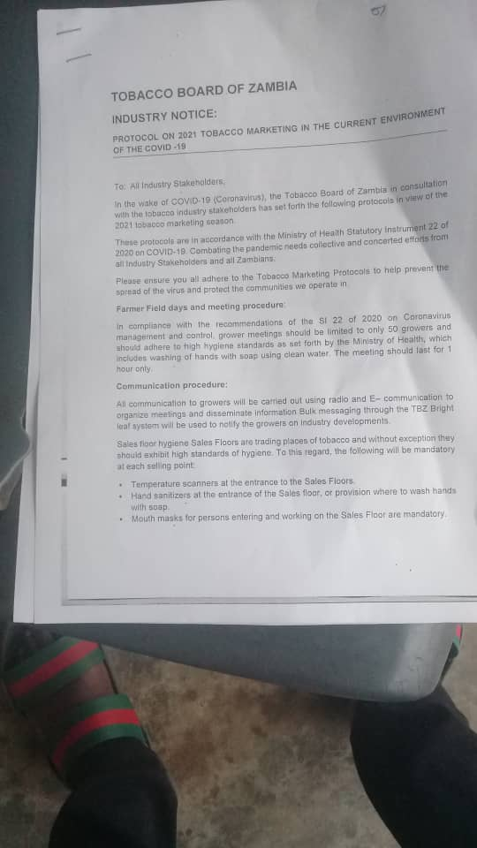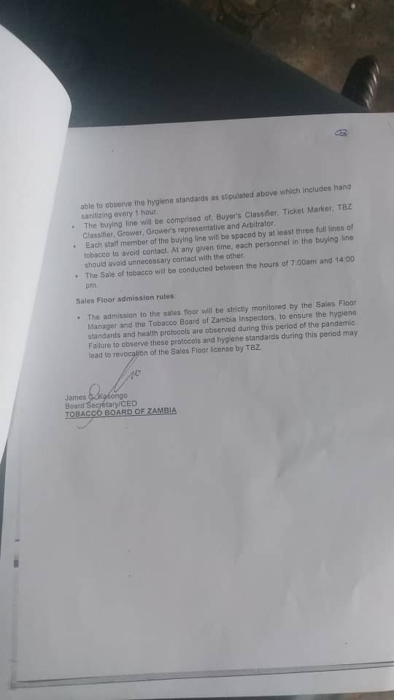

**ANNEX B: BAT TALKS ECONOMIC GROWTH AGENDA[18]**

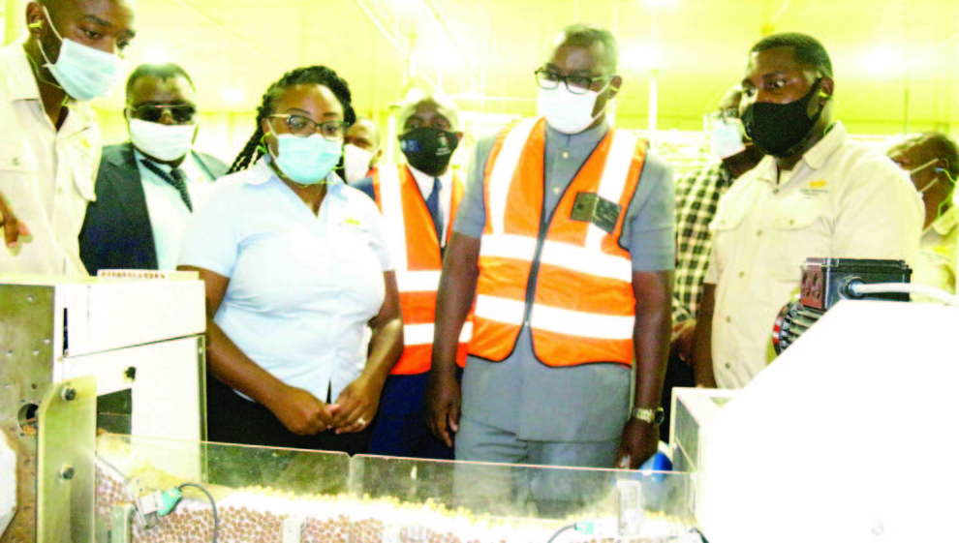

BRITISH AMERICAN TOBACCO ZAMBIA Plc head of legal and external affairs Chipego Chileshe (second left) explaining the cigarette production process to Acting Minister of Commerce, Trade and Industry Mutotwe Kafwaya (second right) in Lusaka.

BRITISH American Tobacco (BAT) Zambia Plc has invested an additional US$800,000 in its production line and assured support in contributing to Zambia’s economic development agenda.

Head of legal and external affairs Chipego Chileshe said the company, which towards the end of last year injected additional capital into the business to develop the new line to be commissioned soon, remains committed to supporting Zambia’s economic growth.  
In 2017, BAT commissioned a US$25 million cigarette manufacturing plant at the Lusaka South Multi Facility Economic Zone (MFEZ).

“From the size of the plant, you can see that it has been built for growth and we will continue doing that; from 2017, when we set up the plant, and we know this will contribute to economic growth going forward,” Mrs. Chileshe said when Acting Minister of Commerce, Trade and Industry Mutotwe Kafwaya toured the processing plant.

**ANNEX C: RUPIAH BANDA VISITS JTI IN CHIPATA**

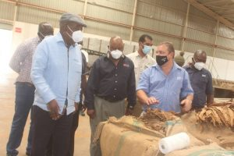

Left to Right: Rupiah Banda and JTI officials at the JTI warehouse

In April 2021, Former Zambian Republican President Rupiah Banda toured the offices and warehouses of the Japan Tobacco International in Chipata where he alleged that the country’s good investment policies are attracting foreign investment and investors need good investment policies.

He said attraction of more investors will be determined by the way the investors who are already in the country are being treated. Mr. Banda said he is impressed with the work of Japan Tobacco International and urged the company to continue. JTI general manager Rob Glen said his company spends about US$5 million in community investments and contracts over 7,000 growers across the country[19].

Mr. Banda further alleged that if JTI is grumbling, they would leave the country and every investor would also follow suit. Mr. Banda said that countries like Dubai attract investors because the rulers of that country have sat down and put in place measures to attract investors, the kind of laws that they make and all those things.

In the same event, JTI general manager Rob Glen said JTI started operating in Zambia in 2010 and that the company had invested about $18 million in infrastructure, about $5 million was in Chipata and the other amount was invested in infrastructure in Western Province and Chisamba. He said the company had about 208 permanent employees and employs about 160 seasonal workers. Glen said JTI loans out $7.8 million to small-scale farmers. He also said JTI would continue ploughing back to the community through its corporate social responsibility programmes. Glen said the company recently helped Chipata Central Hospital, clinics, schools in its area of operation[20].

**ANNEX D: ROLAND IMPERIAL TOBACCO SUPPORTS THE ANNUAL GENERAL ZAMBIA MANUFACTURES WEEK[21]**





**ANNEX E: NEWS PAPER REPORT CALLING FOR INVESTMENT IN TOBACCO PROCESSING[22]**

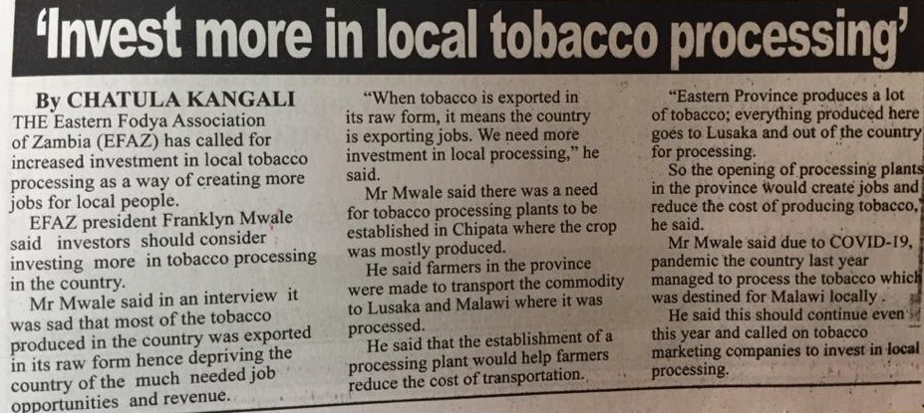

**ANNEX F: NEWS PAPER SEEKING FLEXIBLE MARKETING POLICIES[23]**

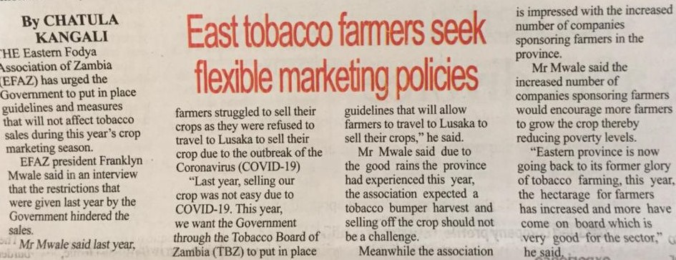

**ANNEX F: NEWS PAPER CLAIMS OF CONTRIBUTING TAXES TO THE GOVERNMENT[24]**

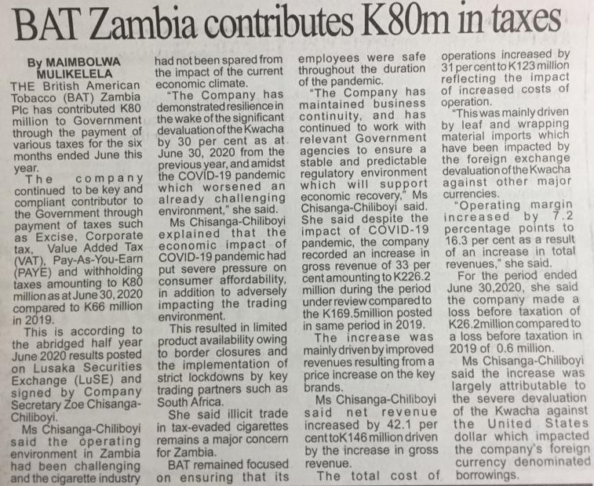

**ANNEX**

**TOBACCO INDUSTRY ACTIVITY**

TOBACCO COMPANIES OPERATING IN ZAMBIA

|  |  |  |
| --- | --- | --- |
| Top 5 Tobacco Companies/distributors | Market Share and Brands | Source |
| British American Tobacco Zambia Plc. | Dunhill, Kent, Pall Mall, Peter Stuyvesant and Lucky Strike | British American Tobacco Zambia https://africanfinancials.com/company/zm-batz/ |
| Japan Tobacco International Zambia Ltd. | Monte Carlo, Aspen Export Menthol, Sweet Menthol, Camel Lights and Camel Full Favour | JTI IN ZAMBIA https://www.jti.com/africa/zambia |
| Roland Imperial Tobacco Zambia Ltd. | LIFE Full Flavor, LIFE Menthol, GUARDS Full Flavor, GUARDS Menthol and Zambezi Cut | Roland Imperial Company https://www.rolandtobacco.com/ |
| Pacific Cigarette Company Ltd. | Pacific Storm, Pacific Breeze, Pacific Mist, Pacific Blue, Acacia, Branson Mint and Branson Flame | Pacific Cigarette Companyhttp://www.pacificcigarette.com/pacific/pacific-blue/ |
| ZAMCAM Tobacco Limited | Esse Change, Esse Change Plus and Compact Black | Zamcam Tobacco Limited https://zamcam-tobacco-limited.business.site/ |

TOBACCO INDUSTRY FRONT GROUPS

|  |  |  |
| --- | --- | --- |
| Top 5 Tobacco Industry Representative | Type (Front Group/ Affiliate/ Individual) | URL |
| Tobacco Board of Zambia Limited | Front Group | https://zambianbusinesstimes.com/amendment-of-outdated-legislation-to-revamp-tobacco-industry/ |
| Toyota Zambia Limited Limited | Affiliate | https://www.africa-newsroom.com/press/handover-ceremony-for-the-project-for-the-construction-of-kabwata-development-youth-centre-in-lusaka |
|  |  | <https://zambiareports.com/2020/06/25/jti-donates-towards-covid-19-fight-eastern-province/> |

NEWS SOURCES

|  |  |  |
| --- | --- | --- |
| Top 5 Newspapers | Type (Print/Online) | URL |
| Zambia Business Times | Online | for-the-project-for-the-construction-of-kabwata-development-youth-centre-in-lusaka |
| Zambia National Broadcasting Corporation | Online | <https://www.znbc.co.zm/news/jti-spends-us300000-on-covid-19-fight-in-western-and-eastern-provinces/> |
| Africa News Room | Online | <https://www.africa-newsroom.com/press/handover-ceremony-for-the-project-for-the-construction-of-kabwata-development-youth-centre-in-lusaka> |
| The Zambia Reports | Online | <https://zambiareports.com/2020/06/25/jti-donates-towards-covid-19-fight-eastern-province/> |
| Zambia Development Agency |  | <https://www.zda.org.zm/index.php/2021/03/26/zda-signs-investment-promotion-and-protection-agreement-with-golden-eagle-tobacco-corporation-limited/> |

1. https://www.who.int/fctc/implementation/fctc2030/investment-case-zambia-who-fctc-2030.pdf
2. https://zambianbusinesstimes.com/amendment-of-outdated-legislation-to-revamp-tobacco-industry/
3. <https://www.znbc.co.zm/news/jti-spends-us300000-on-covid-19-fight-in-western-and-eastern-provinces/>
4. IATA. https://bit.ly/2VOhWSc
5. <https://zambiareports.com/2021/04/30/rupiah-banda-back-form-visits-jti-chipata/>
6. The term “government” refers to any public official whether or not acting within the scope of authority as long as cloaked with such authority or holding out to another as having such authority
7. The term, “tobacco industry’ includes those representing its interests or working to further its interests, including the State-owned tobacco industry.
8. “Offer of assistance” may include draft legislation, technical input, recommendations, oversees study tour
9. https://zambianbusinesstimes.com/amendment-of-outdated-legislation-to-revamp-tobacco-industry/
10. https://zambianbusinesstimes.com/amendment-of-outdated-legislation-to-revamp-tobacco-industry/
11. Please annex a list since 2009 so that the respondent can quantify the frequency, <http://www.who.int/fctc/cop/en/>
12. political, social financial, educations, community, technical expertise or training to counter smuggling or any other forms of contributions
13. <https://www.znbc.co.zm/news/jti-spends-us300000-on-covid-19-fight-in-western-and-eastern-provinces/>
14. IATA. https://bit.ly/2VOhWSc
15. Includes immediate members of the families of the high-level officials
16. <https://www.zda.org.zm/index.php/2021/03/26/zda-signs-investment-promotion-and-protection-agreement-with-golden-eagle-tobacco-corporation-limited/>
17. For purposes of this question, “consistently” means: a. Each time the FCTC is discussed, 5.3 is explained. AND b. Whenever the opportunity arises such when the tobacco industry intervention is discovered or reported.
18. http://www.daily-mail.co.zm/bat-talks-economic-growth-agenda
19. <https://zambiareports.com/2021/04/30/rupiah-banda-back-form-visits-jti-chipata/>
20. <https://www.themastonline.com/2021/05/01/you-dont-attract-investors-by-your-feelings-says-rupiah/>
21. https://web.facebook.com/106598223364285/posts/manufacturers-week-is-here-from-the-22nd-to-27th-of-november-2020-the-zambia-ass/646415772715
22. Kangali M. (2020) Invest more in tobacco processing; Times of Zambia
23. Kangali M. (2020) East tobacco farmers seek flexible marketing policies; Times of Zambia
24. Mulikeka M. (2020)BAT Zambia contributes K80m in taxes ; Times of Zambia